Project Design Phase-II Technology Stack (Architecture & Stack)

|  |  |
| --- | --- |
| **Date** | 05 November 2022 |
| **Team ID** | PNTIBMSm18 |
| **Project Name** | Emerging Methods for Early Detection of Forest Fires |
| **Maximum Marks** | 4 Marks |

Technical Architecture:

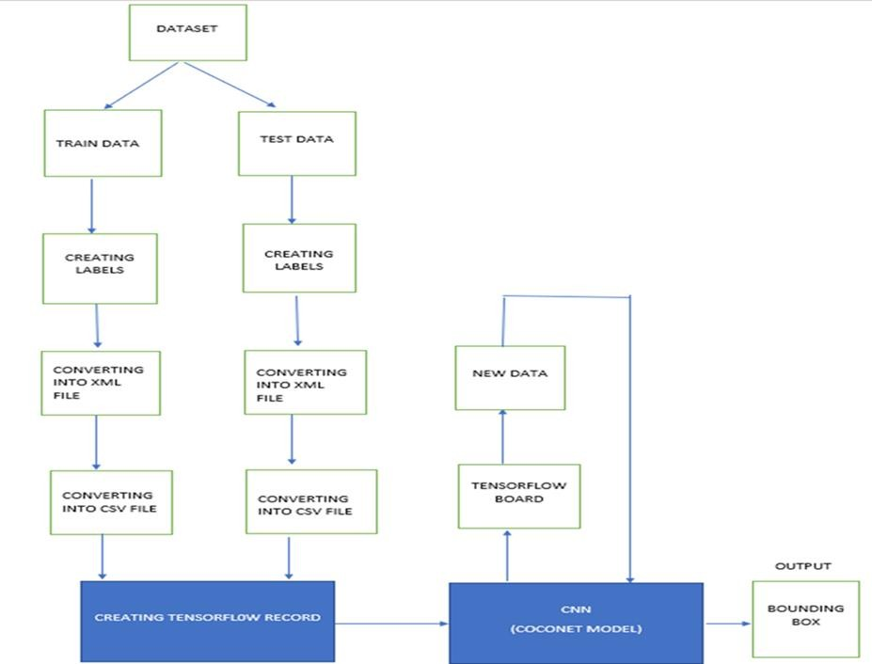

PROBLEM SOLUTION DIAGRAM:



**Test image Processing**

**Detecting with fire or Not**

**Classification Using CNN**

**Predicted Outcome**

**sms**

**HIGHER AUTHORITY**

**PC/LAPTOP**

Table-1 : Components & Technologies:

|  |  |  |  |
| --- | --- | --- | --- |
| **S.No** | **Component** | **Description** | **Technology** |
| 1. | User interface | This project will be interact with real time camera | Image processing |
| 2. | Application logic | Process logic in this project | python |
| 3. | camera | Data processing | Cctv camera |
| 4. | Database | Train and test data folder | Labelled dataset ,From kaggle |
| 5. | Cloud database | Database service | Ibm |
| 6. | Database system | File storage | Local file system on computer or pc |
| 7. | Deep learning model | Purpose of model | Real time object detection and image processing |
| 8. | Infrastructure | deployment | Local and ibm server |

Table-2: Application Characteristics:

|  |  |  |  |
| --- | --- | --- | --- |
| **S.No** | **Characteristics** | **Description** | **Technology** |
| 1. | Open-Source Frameworks | We use open source frameworks and library/modules. | Python,tensorflow  Keras,keras api opencv |
| 2. | Security Implementations | We use real time camera to detect the fire and send the data. | Twilio sms  module,opencv,python |
| 3. | Scalable Architecture | We use image processing technique. | CNN(convolutional nueral  network). |
| 4. | Availability | We use this application to everywhere specailly for forest and place like posible to  fire. | Cctv camera,image/video processing technique called cnn. |
| 5. | Performance | The cnn algorithm is detect the fire with high accuracy compare to other machine / deep learning algorithm. | CNN(convolutional nueral network),image processing. |